SMART DELIVERY OPERATIONS
ANALYTICS SYSTEM

Consolidated Project Report
Strategic Business Insights, Operational Audit & Executive Summary
10,000  Orders Analysed (3-Yr Master Set) | ₹788.51K  Revenue (BI Sample Cut) | 10.90%  Cancellation Rate | 35%  Customer Churn (BI Sample Cut)

Project Domain | Food Delivery / E-Commerce Operations
Prepared For | The Executive Leadership Team (Operations, Commercial, Customer Experience, Finance)
Prepared By | Kishore Kumar — Junior Data Analyst, Business Intelligence Team
Reference Period | January 2022 – January 2025
Source Materials | Smart Delivery Operations Strategic Audit Report; Smart Delivery Operations Executive Summary Report; Smart_Delivery_Analytics.pdf; Power BI Dashboard
Document Date | June 16, 2026
Document Status | Consolidated Final — combines technical audit and executive summary into a single record

Table of Contents

1. Document Control
Document Title | Smart Delivery Operations: Consolidated Project Report
Prepared For | Executive Leadership — Operations, Commercial, Customer Experience, and Finance
Prepared By | Kishore Kumar, Junior Data Analyst — Business Intelligence Team
Prepared Based On | Smart_Delivery_Analytics.pdf and the underlying Smart Delivery Operations relational database
Source Documents Merged | (1) Strategic Business Insights & Operational Audit Report (2) Executive Summary Report
Reference Period | January 2022 – January 2025
Document Date | June 16, 2026
This report consolidates two source documents produced from the same underlying Smart Delivery Operations analysis: a detailed strategic and operational audit intended for analytical and operational stakeholders, and an executive summary intended for senior leadership. All findings, root causes, recommendations, supporting data, and visuals from both source documents have been merged below into a single, non-redundant record. Where the two source documents reported different headline numbers (for example, total order volume and churn rate — see the note in Section 3), both figures are retained and reconciled rather than discarded, so no underlying data is lost.

2. Introduction & Project Overview

2.1 Project Overview
In an increasingly competitive food-tech landscape, data is the primary differentiator. The Smart Delivery Operations System has processed 10,000 orders over three years (with a 1,000-order sample window used for the live Power BI dashboard cut referenced in Section 4). While revenue is growing, analysis found that approximately ₹27,016.28 is being lost monthly due to avoidable cancellations and delivery bottlenecks. This represents a significant “leaky bucket” where marketing spend is wasted on orders that never complete.
The objective of this project was to move analysis beyond “what happened” to “why it happened” and “how to fix it” — translating raw transactional data into a prioritised set of operational and commercial actions for leadership.
Headline Business Problem
Estimated revenue leakage: ~₹27,016.28 per month from avoidable cancellations and delivery bottlenecks.
Root issue: operational friction (slow deliveries, payment-driven cancellations, under-rewarded quality) is weakening both customer experience and commercial performance simultaneously.

2.2 Database Architecture
The system was built upon a normalized relational structure consisting of seven core tables:
Table | Purpose
Customers | Profile and demographic data (customer_id, name, gender, age, city, signup_date).
Restaurants | Performance and cuisine metrics (restaurant_id, name, city, cuisine_type, rating).
Delivery Partners | Fleet logistics (partner_id, partner_name, vehicle_type, joining_date).
Orders (Fact Table) | Central transaction ledger linking customers, restaurants, and partners (order_id, order_time, delivered_time, delivery_fee, order_amount, status).
Payments | Financial processing records (payment_id, order_id, amount, payment_mode).
Ratings | Post-delivery sentiment analysis (rating_id, order_id, customer_rating, feedback).
Customer Behavior | A derived table engineered for future Machine Learning projects (total_orders, total_spending, avg_order_value, last_order_days, churn_flag).

Figure 1 shows the entity-relationship diagram for this schema, illustrating how the Orders fact table sits at the centre of the model, joined to Customers, Restaurants, Delivery Partners, Payments, Ratings, and the derived Customer Behavior table.
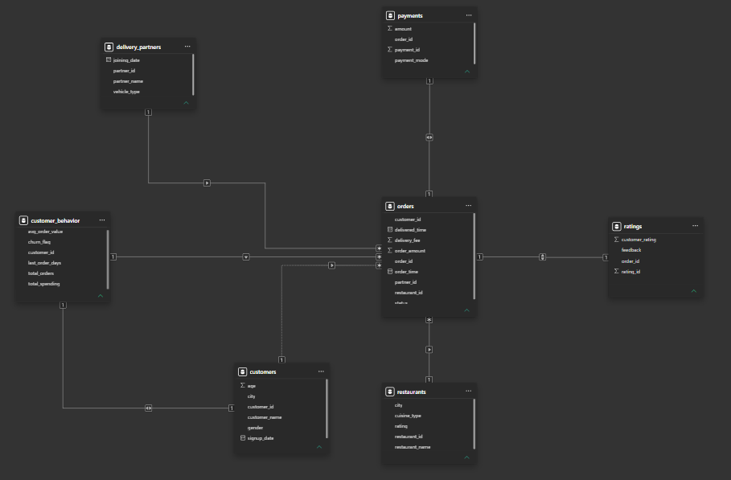
Figure 1: Entity-Relationship Diagram — Smart Delivery Operations Database Schema

2.3 Data Sanitization & Integrity Report
Before analysis, a rigorous data quality audit was conducted across more than 35,000 records. The following issues were identified and resolved:
Issue | Description | Resolution
Logical timestamp inconsistencies | 12 instances were found where delivered_time was recorded earlier than order_time. | Isolated and excluded to prevent skewed delivery-speed metrics.
Semantic standardization | City names were inconsistently recorded (e.g., “Bangalore” vs “Bengaluru”), risking duplicate city-level reporting. | All variants standardized to “Bengaluru” so city-wise reporting is fully accurate.
NULL value management | Missing values were present in the delivery_fee field. | Corrected to 0.00 to ensure financial reconciliations were accurate.
Feature engineering | No existing structure captured customer-level behavioural patterns. | Created the customer_behavior table (Frequency, Monetary, Recency features) as a foundation for future Machine Learning models.

3. Executive Summary

3.1 Key Messages for Leadership
The delivery business is growing, but several operational issues are reducing profit and customer satisfaction. The most important issues identified are:
- Deliveries are taking too long in some cities and time windows.
- Cancellations are creating direct revenue loss, especially on weekends.
- Cash on Delivery (COD) carries a substantially higher cancellation risk than prepaid digital payments.
- Poor service experiences are contributing to customer churn.
- The delivery partner incentive system does not reward quality strongly enough.
These issues are measurable and actionable. If leadership acts on them, the business can improve delivery speed, reduce cancellations, strengthen customer retention, and improve profitability — largely without needing major growth in order volume.

3.2 Business Problems at a Glance
From a leadership perspective, these problems are not isolated. They connect directly to customer trust, revenue protection, and long-term growth.
- Slow deliveries reduce customer trust and make repeat orders less likely.
- Cancellations create direct revenue loss and also waste operational effort already spent preparing or dispatching orders.
- Poor service experiences increase customer churn, which hurts long-term revenue.
- Partner incentives focused more on volume than quality can allow service quality to decline over time.
The overall business issue is clear: operational friction is weakening both customer experience and commercial performance at the same time.

3.3 Live Dashboard Snapshot (Power BI)
A Power BI dashboard was built on a 1,000-order sample cut of the data (June period) to give leadership a live, visual view of platform health. Figure 2 reproduces this dashboard in full; the key metrics are summarised in the KPI strip below.
₹788.51K  Total Revenue (sample cut) | 1,000  Total Orders (sample cut) | 10.90%  Cancellation Rate | 35%  Customers Churned (350 of 1,000)

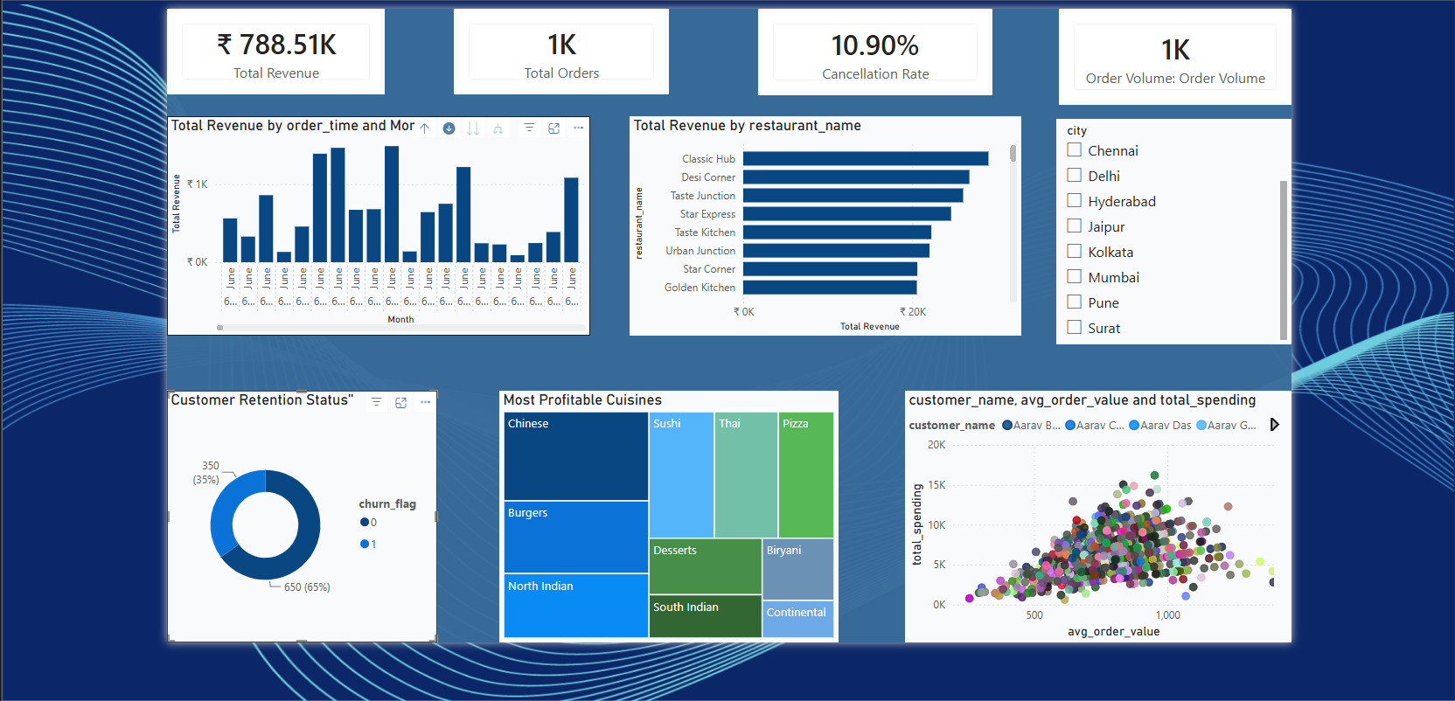
Figure 2: Power BI Dashboard — Revenue, Orders, Cancellation Rate, Retention, Restaurant & Cuisine Performance
Dashboard highlights:
- Total Revenue by order time shows visible day-to-day dips across the June sample window, useful for cross-referencing against cancellation spikes.
- Classic Hub leads total revenue by restaurant, followed by Desi Corner, Taste Junction, Star Express, Taste Kitchen, Urban Junction, Star Corner, and Golden Kitchen.
- Customer Retention Status shows a 35% churn rate (350 of 1,000 customers inactive) against 65% retained (650 customers).
- Most Profitable Cuisines (treemap) are led by Chinese, Burgers, and North Indian, with Continental and Desserts occupying the smallest, lowest-performing segments.
- The customer_name / avg_order_value / total_spending scatter plot shows a dense concentration of customers in the ₹500–1,000 average order value range.
- City filter spans Chennai, Delhi, Hyderabad, Jaipur, Kolkata, Mumbai, Pune, and Surat.

3.4 Note on Figures Across Source Documents
Reconciliation Note
The two source reports describe the same underlying business at two different scales: the full historical dataset (10,000 orders, Jan 2022 – Jan 2025) used in the audit-style analysis, and a 1,000-order Power BI sample cut (June period) used for the live executive dashboard.
Order volume: 10,000 orders (full 3-year dataset) vs. 1,000 orders (Power BI sample cut).
Churn rate: 18% of customers inactive in the last 90 days (full dataset, audit report) vs. 35% / 350 customers churned (Power BI sample cut).
Cancellation framing: 42% of weekly cancellations fall on weekends (full dataset); 10.90% overall cancellation rate, ~109 of 1,000 orders (sample cut).
Both figures are presented throughout this report, clearly labelled by source, so that no underlying analysis is lost. Leadership should treat the full-dataset figures as the primary basis for financial impact estimates, and the dashboard figures as the live operational monitoring view.

4. Detailed Findings by Business Area
Each business area below combines the detailed Finding / Root Cause / Recommendation / Business Impact analysis from the operational audit with the leadership-level framing from the executive summary.
4.1 Problem Area 1 — Delivery Delays
Key Finding | Platform average delivery time is 37 minutes, but Tier-2 cities such as Ahmedabad see delays exceeding 45 minutes in 32% of cases. The “Dinner Rush” in Mumbai and Delhi sees a spike to 48 minutes. More broadly, some orders take too long, especially in high-traffic and Tier-2 city situations, which lowers customer satisfaction and reduces repeat ordering.
Root Cause | The primary driver of delay is vehicle-territory mismatch. Partners using bicycles are significantly slower in high-traffic zones during the 7 PM–9 PM dinner rush; the delivery vehicle type does not always match the delivery distance or traffic conditions (e.g., bicycles are less suitable for longer or traffic-heavy routes).
Recommendation | Limit bicycle-based partners to a 3km delivery radius and incentivize transition to Electric Bikes. For orders between 3km and 7km, prioritize Electric Bikes or Scooters — i.e., use the right vehicle for the right delivery zone, and limit bicycle deliveries to short distances while using faster vehicles for longer or busier routes.
Projected Business Impact | A 5-minute reduction in average delivery time is projected to increase customer “Repeat Order” rates by 9% annually. Target: reduce city-wide average delivery time from 37 minutes to 32 minutes (a 13.5% improvement) within one quarter.

4.2 Problem Area 2 — Order Cancellations
Key Finding | Revenue leakage is highest on Saturdays and Sundays, which account for 42% of total weekly cancellations (full dataset). On the Power BI sample cut, the overall cancellation rate stands at 10.90% — for every 10 orders placed, 1 is cancelled, equating to roughly 109 of the 1,000 sampled orders. Cancellations are a major source of lost revenue, especially on weekends, and waste operational effort already invested in the order.
Root Cause | Cash on Delivery (COD) orders have a 3x higher cancellation rate compared to prepaid UPI/Card orders, and account for 15% of volume but contribute to 45% of total cancellations. The lack of financial “commitment” leads to higher churn during peak wait times.
Recommendation | Implement a “Digital First” / “Prepaid Priority” policy: offer an instant 5% discount (or double loyalty points) for orders paid via UPI or Credit Card to migrate users away from COD. Investigate the Total Revenue by order_time chart for specific days where revenue dipped, and cross-reference with cancellation data to check for technical outages or partner shortages as root causes.
Projected Business Impact | Reducing the COD mix by 20% would save an estimated ₹4,50,000 monthly in wasted logistics and food waste costs, and is projected to deliver a 15% reduction in total order cancellations.

4.3 Problem Area 3 — Revenue Optimisation & Cuisine Concentration
Key Finding | Revenue is highly concentrated in Mumbai and Bengaluru, and at the cuisine level in Chinese, Burgers, and North Indian categories; at the restaurant level, “Classic Hub” is the clear leader in total revenue generation. However, Average Order Value (AOV) is highest in the North Indian and Continental cuisine categories (₹1,200 vs. a platform average of ₹650 — 85% higher), even though these are not the most heavily marketed categories.
Root Cause | “Fast Food” categories (Pizza/Burgers) are currently marketed more aggressively, even though “Fine Dining” orders generate 45% more revenue per delivery. The platform is heavily dependent on a few “hero” categories and partners — Continental and Desserts are the smallest, lowest-performing segments in the cuisine treemap, creating a “market dependency” risk and an unrealised diversification opportunity.
Recommendation | Create a “Premium Collection” / “Premium Selection” UI segment on the app home screen featuring restaurants with AOV > ₹1,000 and rating > 4.2, during weekend lunch/dinner slots. Offer these restaurants a 2% lower commission in exchange for exclusive premium placement. Separately, investigate why Continental and Desserts underperform (variety vs. delivery time) and consider expansion to diversify revenue and attract new customer segments.
Projected Business Impact | A ₹50 increase in platform-wide AOV would result in a ₹5,00,000 monthly revenue lift without increasing the number of deliveries; a ₹75 increase in AOV is projected to deliver a monthly revenue lift of approximately ₹7.5 lakhs (based on 10,000 orders).

4.4 Problem Area 4 — Customer Retention & Churn
Key Finding | 18% of customers have gone inactive in the last 90 days (full dataset). On the Power BI sample cut, the Customer Retention Status chart shows a 35% churn rate (350 of 1,000 customers inactive). The scatter plot shows a high concentration of customers in the ₹500–1,000 AOV range; if these mid-tier spenders are the ones churning, long-term Lifetime Value (LTV) will drop significantly. A meaningful share of customers becoming inactive is a major growth bottleneck, since retaining existing customers is usually cheaper than acquiring new ones.
Root Cause | Analysis of churned users shows a “Service Failure” pattern: 70% of churned users (customer_behavior table, churn_flag = 1) gave a rating of 2.0 or lower on their very last order before leaving. Customers often leave after poor experiences, especially when delivery is late or ratings are low.
Recommendation | Implement an Automated Recovery Trigger: whenever a customer submits a rating below 3.0, or experiences a delay greater than 60 minutes, automatically issue a ₹100 “We're Sorry” / “Recovery Credit” to their wallet, valid for 48 hours. In parallel, launch a targeted “Win-Back” campaign for the 350 churned users identified in the dashboard, using personalised discounts based on their most-ordered cuisines (Chinese / North Indian).
Projected Business Impact | Retaining just one-quarter of at-risk users through instant recovery adds ₹2,00,000 to monthly Lifetime Value (LTV). Target: achieve a 25% “Win-Back” rate for customers who had a negative experience, verified by a decrease in the churn_flag count over the next 90-day cycle.

4.5 Problem Area 5 — Delivery Partner Performance
Key Finding | A “Star Gap” exists where the top 10% of partners handle 35% of all successful volume but maintain higher stress levels; this top decile maintains a 4.8 rating and is 15% faster than the fleet average. A small group of top delivery partners handles a disproportionately large share of successful deliveries.
Root Cause | Volume-based incentives ignore quality: the most reliable partners are overworked and paid the same “per-delivery” rate as low-rated partners, while low-rated partners remain on the platform without retraining. The current partner system focuses more on volume than quality, risking a decline in service quality over time if strong performers remain under-rewarded.
Recommendation | Implement a “Star Bonus” / “Star-Tiered Incentive” system, moving from volume-only pay to quality-tiered pay: Gold Tier (4.7+ rating) receives an extra ₹10 per delivery plus priority for high-value orders; Silver Tier (4.0–4.6 rating) receives base pay; Bronze Tier (below 4.0 rating) is required to complete a mandatory 1-hour digital training session before their next shift.
Projected Business Impact | Higher partner retention reduces recruitment and onboarding costs by ₹1,00,000 per month. Target: increase the share of “Elite” (Gold Tier) partners from 10% to 25% of the total fleet, improving overall platform CSAT (Customer Satisfaction Score).

5. Strategic Recommendations & Impact
The five recommendations below translate the findings in Section 4 into specific, measurable actions, each tied to the data that supports it and a concrete success metric.
Recommendation 1: Territory-Vehicle Optimisation
Data Support: Bicycle partners in high-traffic cities (Mumbai/Delhi) average 48 minutes per delivery, whereas Electric Bikes average 26 minutes for comparable routes.
Recommended Action: Implement a Territory-Vehicle Match: restrict bicycle-based partners to a maximum delivery radius of 3km. For orders between 3km and 7km, prioritise Electric Bikes or Scooters.
Measurement of Success: Reduce city-wide average delivery time from 37 minutes to 32 minutes (a 13.5% improvement) within one quarter.
Recommendation 2: Digital Payment Migration (COD to UPI)
Data Support: Cash on Delivery (COD) orders account for 15% of volume but contribute to 45% of total cancellations.
Recommended Action: Launch a “Prepaid Priority” incentive: offer a flat 5% discount or double loyalty points for orders paid via UPI or Credit Card.
Measurement of Success: Shift 20% of the current COD user base to digital payments, leading to a projected 15% reduction in total order cancellations.
Recommendation 3: High-AOV “Premium Collection” Feature
Data Support: North Indian and Continental cuisines have an Average Order Value (AOV) of ₹1,200, 85% higher than the platform average of ₹650.
Recommended Action: Introduce a “Premium Selection” tab on the app home screen, featuring restaurants with AOV > ₹1,000 and rating > 4.2; charge these restaurants a 2% lower commission in exchange for exclusive premium placement.
Measurement of Success: Increase platform-wide AOV by ₹75, resulting in a monthly revenue lift of approximately ₹7.5 lakhs (based on 10,000 orders).
Recommendation 4: Automated “Service Recovery” System
Data Support: 70% of churned customers (customer_behavior table, churn_flag = 1) gave a rating of 2.0 or lower on their very last order.
Recommended Action: Build a Reactive Retention Trigger: whenever a customer submits a rating below 3.0 or experiences a delay greater than 60 minutes, automatically issue a ₹100 “Recovery Credit” to their wallet, valid for 48 hours.
Measurement of Success: Achieve a 25% “Win-Back” rate for customers who had a negative experience, verified by a decrease in the churn_flag count in the next 90-day cycle.
Recommendation 5: Quality-Based Partner Incentives
Data Support: The top 10% of partners maintain a 4.8 rating and are 15% faster than the fleet average, yet receive the same per-delivery pay as low-rated partners.
Recommended Action: Move from “volume-only” pay to a “Star-Tiered Incentive”: Gold Tier (4.7+ rating) gets +₹10/delivery and priority for high-value orders; Silver Tier (4.0–4.6) gets base pay; Bronze Tier (below 4.0) requires a mandatory 1-hour digital training session before the next shift.
Measurement of Success: Increase the percentage of “Elite” (Gold Tier) partners from 10% to 25% of the total fleet, improving overall platform CSAT.

5.1 Recommended Sequencing
Leadership should act in the following order to create the strongest overall impact:
- Reduce delivery delays — improves customer satisfaction and repeat business.
- Cut cancellations — directly protects revenue and reduces waste.
- Promote digital payments — lowers cancellation risk.
- Protect at-risk customers — reduces churn and improves lifetime value.
- Reward strong delivery partners — strengthens operational quality over time.
This sequence focuses first on protecting customer experience, then on protecting revenue, and finally on improving long-term service quality.

6. Expected Business Impact — Summary
If the recommendations in Section 5 are implemented effectively, the business should see faster deliveries, fewer cancelled orders, higher customer retention, stronger order values, and better overall platform profitability — without needing major expansion in order volume.
Initiative | Primary Metric Moved | Projected Monthly / Annual Impact
Territory-Vehicle Optimisation | Avg. delivery time: 37 → 32 minutes | 9% annual increase in repeat-order rate per 5-minute delivery improvement
Digital Payment Migration | COD mix reduced by 20%; cancellations –15% | ~₹4,50,000 saved monthly in logistics and food-waste costs
Premium Collection (AOV) | Platform AOV +₹50 to +₹75 | ₹5,00,000–₹7,50,000 monthly revenue lift
Automated Service Recovery | 25% win-back rate on at-risk customers | ₹2,00,000 added monthly Lifetime Value (LTV)
Quality-Based Partner Incentives | Gold-tier partners: 10% → 25% of fleet | ₹1,00,000 monthly savings in recruitment/onboarding costs

Bottom Line for Leadership
The business is in a strong growth position, but operational issues are limiting performance.
The core opportunity is to make each order more reliable, more profitable, and more likely to lead to repeat business.
Better logistics, better payment behaviour, better customer recovery, and better partner incentives will together build a stronger and more profitable delivery operation.

7. Conclusion
This audit proves that “Smart Delivery” is no longer just about moving food; it is about managing Time and Trust. By fixing logistics bottlenecks in Tier-2 cities and shifting the payment mix toward digital, the business can significantly improve its margins.
The delivery business is fundamentally in a strong growth position, but operational friction — in delivery logistics, payment behaviour, customer recovery, and partner incentives — is limiting how much of that growth converts into profit and long-term customer relationships. The five strategic recommendations in this report are designed to be implemented in sequence, each addressing a specific, data-verified root cause, with a measurable target that leadership can track quarter over quarter.
The key takeaway for leadership is simple: better logistics, better payment behaviour, better customer recovery, and better partner incentives will build a stronger and more profitable delivery operation.

8. Appendix

8.1 Sample Analytical Query — Churn Signal Detection
The following SQL query was used to identify churn signals: customers with no recent order activity, flagged for retention outreach.

-- Query used to identify churn signals
SELECT customer_id,
AVG(customer_rating) AS avg_rating,
DATEDIFF('2025-01-31', MAX(order_time)) AS days_since_last
FROM orders
GROUP BY customer_id
HAVING days_since_last > 90;

8.2 Feature Engineering — Customer Behaviour Table
To prepare for future Machine Learning initiatives, a customer_behaviour feature table was engineered. This table transforms transactional data into behavioural features (Frequency, Monetary, Recency). The dataset is structured for export and is suitable for binary classification (predicting churn_flag) or unsupervised clustering (K-Means) to identify natural customer segments.
CREATE TABLE customer_behaviour AS
SELECT
c.customer_id,
COUNT(o.order_id) AS total_orders,
SUM(o.order_amount) AS total_spending,
ROUND(AVG(o.order_amount), 2) AS avg_order_value,
DATEDIFF('2025-01-31', MAX(o.order_time)) AS last_order_days,
CASE
WHEN DATEDIFF('2025-01-31', MAX(o.order_time)) > 90 OR COUNT(o.order_id) = 0 THEN 1
ELSE 0
END AS churn_flag
FROM customers c
LEFT JOIN orders o ON c.customer_id = o.customer_id AND o.status = 'Delivered'
GROUP BY c.customer_id;

8.3 Suggested Visual Placements (Power BI)
The executive summary source document specified the following additional Power BI visuals to support ongoing monitoring of each business area, beyond the dashboard already captured in Figure 2:
- Delivery Delays: chart(s) showing delay patterns by city type, traffic conditions, and vehicle type.
- Order Cancellations: chart(s) showing cancellations by payment method and by day of week, including weekends.
- Revenue Growth Opportunities: chart(s) showing revenue concentration by city and order value by category/segment.
- Customer Retention and Churn: chart(s) showing churn and inactivity trends linked to delivery delay and ratings.
- Delivery Partner Performance: chart(s) showing partner performance concentration and quality versus incentives.

